Our Ref: _______________ Your Ref: ________________________ Date: __________________

Baptist Church

Baale Yaku Site Area, P. O. Box 644,

Ogbomoso, Oyo State. Tel. 07052425407

Email: [newsprinbaptistchurch@gmail.com](mailto:newsprinbaptistchurch@gmail.com)

Website: newspringbc.comze.com

NEW SPRING

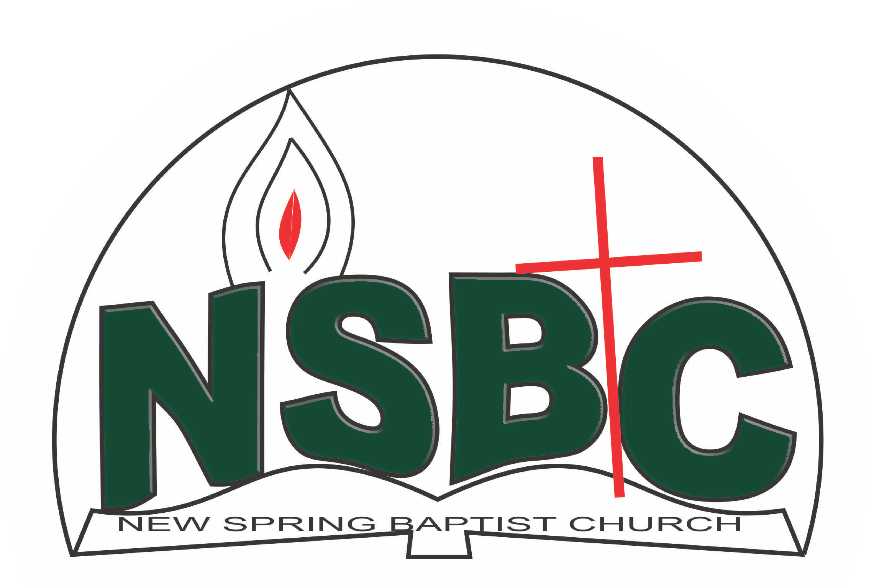

2 January 2022

Dear Miss Mercy Oketoobo,

Nomination to Serve as anOfficer and Worker in the Church in 2022

Calvary greetings in the precious name of our Lord and Saviour Jesus Christ. It is our pleasure to inform you that at the Church-in-Conference held on December 19, 2021; the Church ratified your nomination to serve in this area between January 1 and December 31, 2022:

1. Member, Church Ushers under the leadership of Mr. Nathaniel Oyekunle (Teenagers)

Please refer to the table below for the key functions of each of these roles. Details can be found in the Church constitution. You are strongly encouraged to become familiar with the tasks as stated in the document. There will be an orientation of the Church workers on January 22, 2022 at 8:30 a.m. on the church premises. Please ensure you participate in this training.

“Now it is required that those who have been given a trust must prove faithful. I Corinthians 4:2”. May God find you faithful in the task He has assigned to you.

| Domain | Key function of Office, Department or Committee |
| --- | --- |
| Teenagers Church Ushers | To provide support to the Church Pastor in guiding members and visitors to appropriate seating locations before and during service |

Thank you for accepting to serve in this Church.

Yours in His service

Olusayo Okediji Blessed Agboola

Church Secretary                                                                                     Chairman, Nominating Committee